**IOT BASED SMART PARKING SYSTEM**

A Project report submitted in partial fulfilment of the requirements for the degree of B.E in Computer Science and Engineering.

**By**

B.JEEVITHA(513221104010)

Under the supervision of Professor & HOD Department of Computer science and Engineering.

SMART PARKING SYSTEM

Phase 2: Innovation

INNOVATION PARKING POLICIES:

* To begin with, the city council needs to fight the issue at the source. They need to define high-traffic areas and subsidize parking in quieter areas.
* CEOs and building managers are encouraged to research parking policy examples to improve their employees’, clients’, and customers’ experience.
* However, smart parking innovations simplify this for everyone: the CEO, the commercial real estate agent, the student, the employee, the resident–the whole city benefits.



BEST SMART PARKING INNOVATION IDEA :

1. Smart parking sensors
2. Parking applications
3. Stacked parking
4. Subterra parking lifts
5. Reduced fees for EVs
6. Robot valet parking
7. Solar panels parking shades

Problem Statement:

* In public places where there are many visitors, a lot of time is wasted for searching parking slots and how to reduce the time for searching the spot to parking the car.
* SOLUTION: Also, a lot of manual labour is required to look after the existing parking arrangement. Moreover, there is no way of knowing whether a vacant parking space is available or not.
* By using ultrasonic sensors be able to keep a record of the number of cars parked inside of a parking garage.

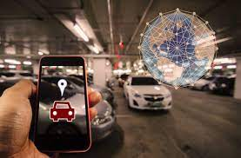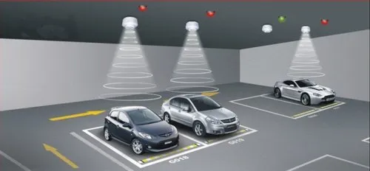

Best innovation design of the smart parking system in using some sensors and software systems.

**What is the Innovation new parking technology**:

* AI-based smart parking is an innovative solution that harnesses data from various devices such as sensors and cameras to create an intelligent parking management system.
* These devices are either retrofitted within parking lots or placed in close proximity to detect the availability of parking spots

**Explore some innovative strategies that can help you make it happen.**

* Update Your Lighting. ...
* Make It More Accessible. ...
* Create More Parking Space. ...
* Invest in Green Space. ...
* Upgrade Security Solutions. ...
* Utilize Smart Parking Sensors. ...
* Incorporate Touchless Entry and Exit.

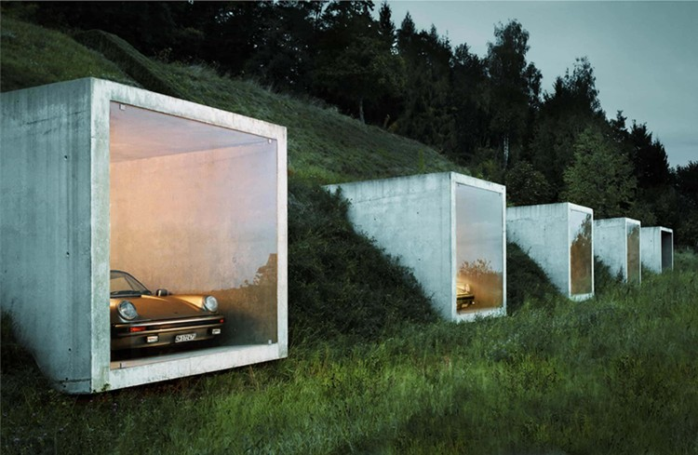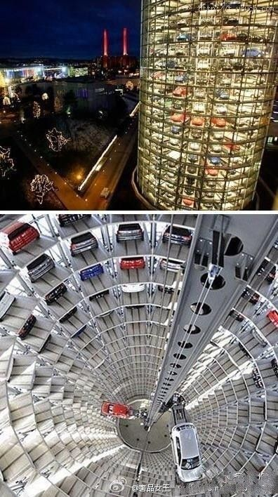

* Above image is defined by most innovative and different model parking systems .It is very easy to parking the car and reduce the time by persons.

Innovations in Smart Parking Taking Cities into the Future:

* Tracking Sensors
* Automated Parking
* Parking Counter
* Safety Controls

**THANKING YOU**